- Domain (interval)_________________ Range (interval)__________________
Max or Min_________________
End Behavior_______________
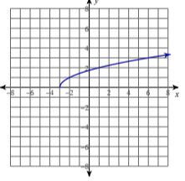
Parent Function______________
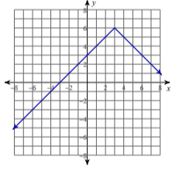

3.
Domain(inequality) _______________
Range (inequality)_________________
End Behavior____________
Max or Min______________
Parent Function_____________
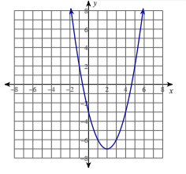

- Domain (set)__________________
Range (set)__________________
Max or Min_________________
End Behavior___________________
Parent Function_______________

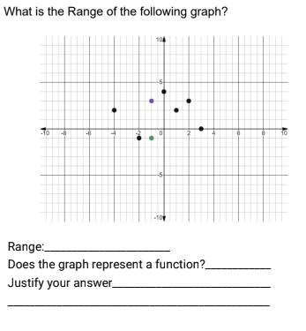
4.

5. Which of these represent a linear function?
Circle all that apply.
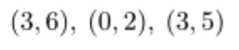
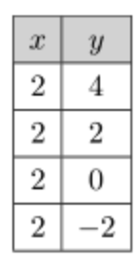
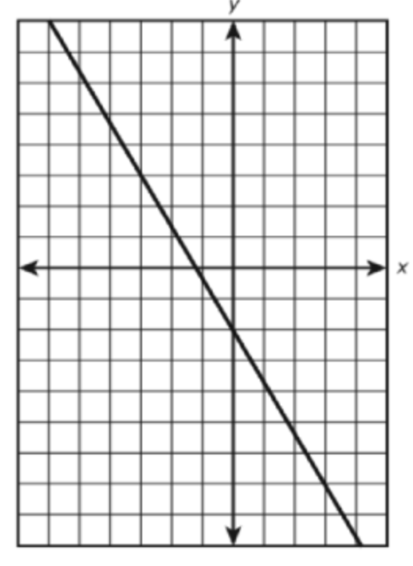
- c.

- For each square whose side length is
s, the perimeter is 4s.

- $y=|x|$
_________________________________________
6. The hang time (in seconds) for a football
that has been kicked into the air is given by
$T(h)=\frac{\sqrt{h}}{2}$
where $h$ represents the maximum height of the football. Which of the following is the most
Reasonable domain for this situation?

- All real Numbers c. $[0,∞)$
- $(0,∞)$ d. $[0,60]$
________________________________________
7. Officials in a town use a function, C, to analyze traffic patterns. C(n) represents the rate of traffic through an intersection where n is the number of observed vehicles in a specified time interval. What would be the most appropriate domain for the function?

1) {. . . 2,1,0,1,2,3,. . . }
2) {2,1,0,1,2,3}
3) {0, $\frac{1}{2}$ ,1,$1\frac{1}{2}$, 2, $2\frac{1}{2}$, 3,...}
4) {0,1,2,3,. . . }

7. How do the graphs of $f(x) =x$ and $g(x)=|x|$ Compare?

a) $f(x)=g(x)$ for $x≥0$ b) $f(x)=g(x)$ for $x<0$c) $f(x)=g(x)$ for $x>0$ d) $f(x)=g(x)$ for $x≤0$ e) $f(x)=g(x)$ for all values of $x$
___________________________________________
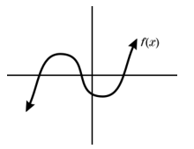

8. Use the graph of $f(x)$ to determine which statement is false.

- The domain range of this function are equal
- The domain of $y=x^{2}$is the same as the domain of $f$
- $f$ is continuous for all the real numbers
- The range of $y=|x|$ is the same as the range of $f$
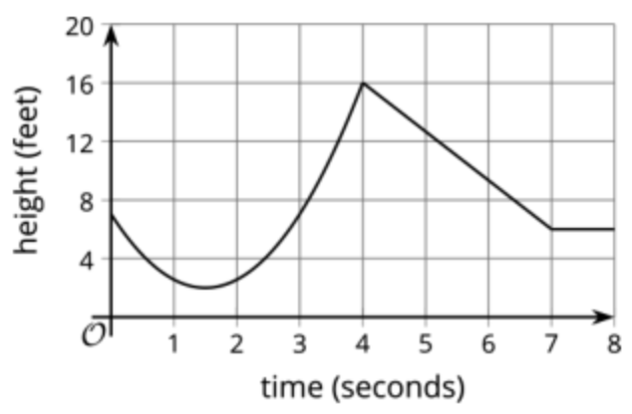
____________________________________________
9.

Write a coordinate point for each feature on the graph. If the feature does not exist, write “None”. Maximum:_________ Minimum:_______
y- intercept:______ x-Intercept:_________
Use interval notation to indicate the following.
Intervals increasing:___________________
Intervals decreasing___________________
Intervals constant:____________________

